Smart Public Restroom

Introduction:

* The project Development of a smart toilet for automatic flushing deals with automatic cleaning of Indian toilets without requiring any human assistance.
* Smart restrooms in airports are technologically advanced restroom facilities that use various sensors, automation, and data analysis to improve hygiene, maintenance, and user experience.
* Many smart toilets have automatic flushing and hands-free operation (especially after COVID) to help keep surfaces and floors clean.
* Most of the public toilets are not clean due to the irresponsible peoples who often forget to flush the toilet after using it.
* In India all the state and central government are allotting numerous funds for constructing public toilets.
* The central government under “SWACH BHARAT MISSION” has built a vast amount of new toilets to provide the citizens a healthy and hygienic environment.
* Therefore cleaning of public toilets is equally important as cleaning of household toilets.
* So we have developed a mechanism to flush the toilets automatically by utilizing the human weight.
* The mechanism does not require any external power or human concern.Rather, it just works mechanically utilizing the weight of the person sitting on it.
* Our smart toilet is the only system in the markets offering concealed arms over the bowl to clean and dry the bowl and surrounding walls up to 80cm.
* High-pressure ejecting water is mixed with disinfectant; a floor-integrated high-pressure nozzle system ejects water and disinfectant on the floor.

Materials Required:

* Aurdino
* Aurdino IDE Software
* Ultrasonic sensor
* DC Motor
* LCD
* Potentiometer
* Breadboard
* Led
* Resistor

Diagram:

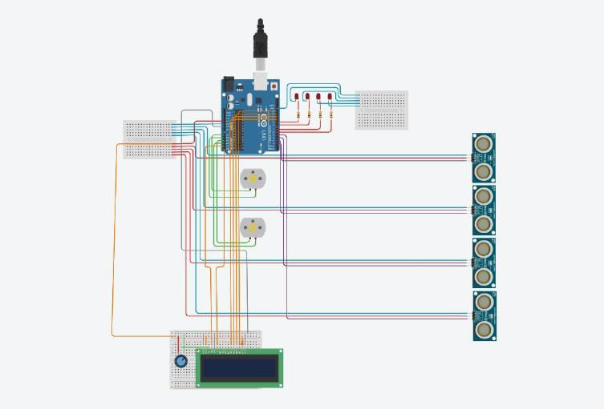

Software Used:

* Arduino Integrated Development Environment (IDE) is an open source IDE that allows users to write code and upload it to any Arduino board.
* Arduino IDE is written in Java and is compatible with Windows, macOS and Linux operating systems.
* Arduino is important part in robotics because it provide creativity and problem-solving.
* It is plugged in the computer and programmed with easy commands i.e. when Arduino is placed in a circuit, and it will manipulate the functioning of the device.
* It emphasizes the involvement of Arduino in many things around.

Circuit Diagram:

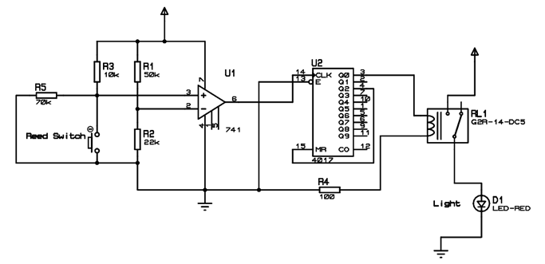

Content :

* Automated or touchless fixtures like faucets, soap dispensers, and flush mechanisms to minimize contact with surfaces.
* Install remote monitoring and diagnostics.
* Implement predictive maintenance.
* Train staff on technology usage.
* Motion-sensor lighting and climate control to reduce energy consumption when the restroom is not in use.
* Solar panels or other renewable energy sources to power restroom facilities.

Coding:

#include <Servo.h>

#include <LiquidCrystal.h>

const int niagraMinDistance = 3;

const int niagraMaxDistance = 335;

const int trig = 7;

const int echo = 8;

const int servo = 9;

const int pingPin = 2;

const int echoPin = 3;

const int d4 = 4, d5 = 5, d6 = 6, d12 = 12;

const int rs = 10;

const int en = 11;

const int a0 = 14;

const int a1 = 15;

const int a2 = 16;

bool sitOn = false;

long duration, distance, distanceSit, duration1, a[3], starttime, endtime;

float cm = 1.1;

Servo myServo;

Servo myServoSit;

LiquidCrystal lcd(rs, en, d4, d5, d6, d12);

void setup() {

pinMode(pingPin, OUTPUT); // set ping Out

pinMode(echoPin, INPUT); // set echo In

lcd.begin(16, 2); // initialize LCD

Serial.begin(9600); // Initialize Serial

myServo.attach(servo);

pinMode(trig, OUTPUT);

pinMode(echo, INPUT);

myServo.write(180); // servo position 180 degree (can also be 0 if we want it to turn to the other way)

delay(1000);

myServo.detach();

myServoSit.attach(a2);

pinMode(a1, OUTPUT);

pinMode(a0, INPUT);

myServoSit.write(180); // servo position 180 degree (can also be 0 if we want it to turn to the other way)

delay(1000);

myServoSit.detach();

}

// Measures the distance from our hand to the the sensor

void measureServo() {

digitalWrite(trig, LOW);

delayMicroseconds(6);

digitalWrite(trig, HIGH);

delayMicroseconds(15);

digitalWrite(trig, LOW);

pinMode(echo, INPUT);

duration = pulseIn(echo, HIGH);

distance = (duration/2) / 29.1;

}

void measureServoSit() {

digitalWrite(a1, LOW);

delayMicroseconds(6);

digitalWrite(a1, HIGH);

delayMicroseconds(15);

digitalWrite(a1, LOW);

pinMode(a0, INPUT);

duration = pulseIn(a0, HIGH);

distanceSit = (duration/2) / 29.1;

}

// Measures the distance from the float inside niagara to the sensor

void measureDistanceFloat() {

digitalWrite(pingPin, LOW);

delayMicroseconds(2);

digitalWrite(pingPin, HIGH);

delayMicroseconds(10);

digitalWrite(pingPin, LOW);

duration1 = pulseIn(echoPin, HIGH);

}

// Convert data from input pins to cm

long microsecondsToCentimeters(long microseconds) {

return microseconds / 29 / 2;

}

void printDistanceToLCD(int cm) {

lcd.clear();

lcd.setCursor(0, 0);

lcd.print("Progress until");

lcd.setCursor(0, 1);

lcd.print("full tank: ");

lcd.print(100 - ((double)cm / (niagraMaxDistance - niagraMinDistance)) \* 100.0);

lcd.print("%");

}

void printDistanceToSerial(int cm) {

Serial.print(cm);

Serial.print(" cm");

Serial.println();

}

void loop() {

measureDistanceFloat();

cm = microsecondsToCentimeters(duration1);

printDistanceToLCD(cm);

printDistanceToSerial(cm);

for (int i = 0; i <= 2; i++) {

measureServo();

measureServoSit();

a[i]=distance;

delay(50);

}

distance = (a[0] + a[1] + a[2]) / 3;

if (distance < 70) {

myServo.attach(servo);

delay(1);

myServo.write(90); // Servo position 90 degree

delay(2000);

myServo.write(180); // Servo position 180 degree

delay(1000); // Waiting for the water to flush down

myServo.detach();

}

if (distanceSit < 70 && !sitOn) {

starttime = millis();

myServoSit.attach(a2);

delay(1);

myServoSit.write(90);

sitOn = true;

}

else if (distanceSit < 70 && sitOn) {

myServoSit.attach(a2);

delay(1);

myServoSit.write(180);

sitOn = false;

}

endtime = millis();

if (((endtime - starttime) >= 900000) && sitOn)

{

myServoSit.attach(a2);

delay(1);

myServoSit.write(180);

sitOn = false;

}

}

Advantages:

* No sensors or electronics involved.
* No human effort required.
* Mechanism is robust.
* Economical.

DRAWBACKS:

* Continuous Monitoring.
* Battery Maintenance.
* Sensor Requirement.
* Costly.